(HONORS) GEOMETRY NAME: _____________________
Unit 9 Lesson 4 Homework – Areas of Sectors and Circles BLK: _____ DATE: ___________

1. Find the area of the circle. Leave answer in terms of pi.

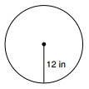

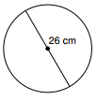
2. Find the area of the circle. Leave answer in terms of pi.

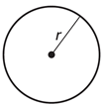
3. Find the radius of a circle with an area of $169π$ square inches.

4. Find the area of the shape below.

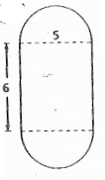

5. Find the area of the indicated sector.

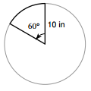

6. Find the area of the indicated sector.
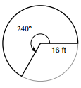

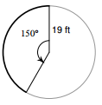
7. Find the area of the indicated sector.

8. Find the area of the indicated sector.
